China’s Pork Boom
Yuxi Jiang
Introduction
Since 1979, pork has been the world’s most produced and consumed meat. The credit of pork’s successful ascent to the top should have gone to China (Schneider, 2011). In 2010 alone, China produced 50 million metric tons of pork, which is “twice the amount of pork produced in all 27 EU countries combined, five times the amount in the United States and almost half of the global total of 101.5 million metric tons.” This sudden jump in production was accelerated by Chinese people’s rising appetite. In the mid-1970s, an average Chinese citizen consumed about 9 kilograms of pork a years. At the present, shown in figure 1, however, an average Chinese citizen is consuming about 39 kilograms of pork annually, while Americans et around 27 kilograms (Brasch, 2014). In addition, China’s domestic consumption basically matched its domestic production. The production and consumption of pork in China are still growing. In 2014, pork production is expected to increase to 54.7 million tons accompanied with an expected consumption of 55 million tons. In the long term, the OECD-FAO predicted that China’s pork production would have an annual increase at 1.5 percent (Schneider & Sharma, 2014). Although China’s huge production and consumption of pork can be partly explained by some historical and social factors, however, its rapidly increasing trend is mainly the result of the liberalization and industrialization of Chinese agriculture since the Reform and Opening-up, which enabled enormous production increases (Schneider, 2011).
Why Chinese people love pork so much: Culture and History
Pig husbandry in China can date back to as many as 10,000 years ago. It is also a significant part of Chinese language. In Mandarin, when you say “meat” (rou), people will naturally think it as “pork.” In addition, the Chinese character for “home” (jia) is made up by adding the roof radical to the pig radical, which almost indicated, “A roof over a pig makes a home” (Brasch, 2014).
In addition, pigs for thousands of years in China were valued for being a marker of wealth. They were served as celebration meals. Thus, by increasing the production and making pork cheaper, Chinese government is demonstrating its wealth to the whole world (Brasch, 2014).
Why pork production grows so fast: Industrialization
The first national survey of indigenous livestock in 1960 taken by the Chinese Academy of Agricultural Sciences showed that “local people raised local pigs and ate them in local contexts.” However, when policies and markets began to change, swine husbandry and consumption became much more diverse since the end of the 20th century (Schneider, 2011). Trying hard to increase meat consumption for 1.3 billion people on only 120 million hectares of arable land, Chinese government officials decided to replicate the dominant and unsustainable U.S. model at an even larger scale by financially and politically supporting medium- to large- scale industrial operations (Schneider & Sharma, 2014). Agribusiness firms are controlling much of the meat production and sale processes, while smallholder farmers either quit pig production, become specialized hog producers, or become migrant laborers (Schneider & Sharma, 2014).
Production Forms
Three forms of pig production emerged in the process of industrialization.
The first form is “backyard farms”. As recently as 1985, small-scale backyard farmers produced at 95 percent of the country’s pork. Before the government liberalized agricultural markets in the 1980s, these small-scale farmers usually produced two pigs annually: one for self consumption during Spring Festival, and one for selling at prices set by the state to government purchasing stations. Pig was functioning as a low-carbon and low-pollution fertilizer. However, today, with the process of high-pace urbanization and marketization, small-scale farmers, mainly comprised of women and the elder, only account for about 27 percent of national pork production shown in Figure 2 (Schneider & Sharma, 2014).
The second form is “large-scale commercial farms.” Deng Xiaoping’s economic reforms in 1978 encouraged private businesses and foreign investment in China. The trend of husbandry was continuously moving towards large-scale commercial pig raising. The commercial farms only accounted for 2.5 percent of national pork production in 1985, but by 2007, they already accounted for 22 percent. Most of these farms are domestic enterprises with a salient feature of vertical integration (Schneider, 2011).
The third form is “specialized household farms.” It is an important middle-scale production operation with annual pig production from 10 to 500 head. These farms are usually run by individual families or by several backyard farmers joining together with the help of government subsidies. Though backyard remains the primary site for operation in this model, however, different from the “backyard farms,” the production of these pigs is for sale instead of self-consumption (Schneider, 2011).
Feeding Industry
The industrialization of pig raising in China fueled the development of a multi-billion dollar feed industry. In order to feed millions of pigs, with the convenience resulted from joining WTO, China became the world's leading soybean importer. In 2010, China imported more than 50 million metric tons of soybeans, which accounted for 73 percent of soybean consumption in China. Worth noticing here, unlike the production industry, most companies of the soybean crushing industry in China are transnational agribusiness firms (Schneider, 2011).
Furthermore, while soybean is a crucial element in commercial pig feed mixes, corn is important for the feedstuff used by smallholders and specialized household farmers. Recently, corn is increasingly used as commercial livestock feed. In 2010, China for the first time became a net corn importer since 1995 (Schneider, 2011).
Impacts
The rapidly growing pig production and feeding industries would have serious impacts on the environment, society, and people’s health. Due to the length requirement of this memo, I would focus on the environmental impacts here, which have always been neglected by many people.
Water and Soil Pollution
The fast development of livestock breeding becomes a major source of pollution. Fertilizer- and pesticide-containing runoff from the crop fields used for livestock feeding would severely pollute water. In addition, besides fertilizer and pesticide, manure is another important source of water pollution. The massive increase of animal waste from the livestock industry is leading to nutrient overload on land and in waterways (Schneider, 2011). Although there are some existing manure management methods, these methods are flawed with problems for ecosystems and human health. The contaminants from industrial factory farms also include pesticides, heavy metal, and other pathogens (Schneider & Sharma, 2014).
Air Pollution and Green Gas Emissions
The production and storage of manure also release many air pollutants such as the dead skin cells of animals and ammonia (Schneider & Sharma, 2014). Furthermore, the livestock industry can emit three main greenhouse gases in significant amounts: carbon dioxide, methane and nitrous oxide. Carbon dioxide is emitted in every state of livestock products and feed production and accounts for 9 percent of worldwide emissions. Methane is mainly from enteric fermentation and manure and accounts for 37 percent of global human-made methane emissions (Schneider, 2011).
Genetic and Species Diversity
Chinese farmers have development more than 6000 varieties of soybeans in a time span of thousands of years, accounting for 90 percent of the soybean varieties in the world. However, in order to meet the dietary needs, today, the soybean industry is only made up of a few varieties. Even worse, if GM soy production gets permitted in China, then probably most wild types would be eliminated （Schneider, 2011).
In addition, the variety of pigs in China is also significantly reduced. Three exotic breeds have replaced more than 100 indigenous pig breeds in order to quickly convert feed into lean pork to satisfy the industrialization needs. Relying on a narrow range of livestock breeds would cause loss of genetic trait, increase in vulnerability, and the extinction of local breeds (Schneider, 2011).
Antibiotic Resistance
Industrial livestock feeding requires antibiotic doses throughout the whole production cycle in order to prevent disease and promote growth. The overuse of antibiotics would lead to the rapid emergence of antibiotic-resistant and disease-causing organisms, making it hard to treat disease in both humans and other animals using medicines (Schneider, 2011).
Conclusion
Given the increasing demand of pork under the national context of rapid economic development, it seems industrialization of pork production will continue to grow and expand in China. Thus, it is for Chinese authorities and researchers to further explore what possible methods can effectively and efficiently alleviate the negative environmental, social, and health-related impacts of pork industrialization.

Works Cited
Brasch, S. (2014, March 11). How China became the world's largest pork producer.
Retrieved November 2, 2014, from Modern Farmer:
http://modernfarmer.com/2014/03/tail-curling-facts-chinese-pork/
Schneider, M. (2011). Feeding China's pigs: Implications for the environment, China's
smallhoder famers and food security. n.a: Institue for Agriculture and Trade Policy.
Schneider, M., & Sharma, S. (2014). China's pork miracle? Agribusiness and develoment in
China's pork industry. n.a.: Institute for Agriculture and Trade Policy.

Appendix
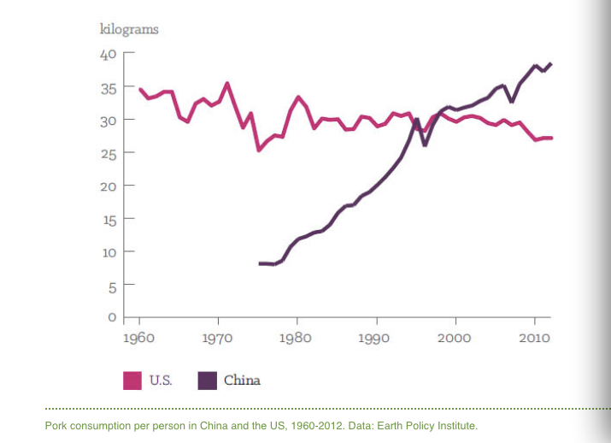
Figure 1. Pork Consumption Per Person in China and the US, 1960 – 2012 (Schneider, 2011).

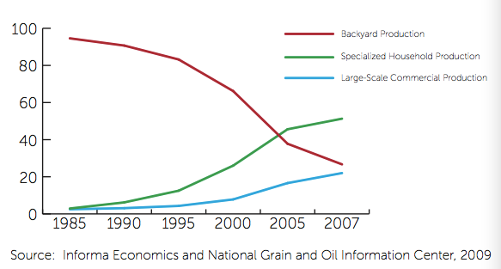
Figure 2. Share of Total China Pig Production by Farm Type: 1985 – 2007 (%) (Schneider, 2011).

